This battle is a battle for dominance between Bio Mechanical Invasion (BMI) and Phantoms

Moon City is a new city too close to a caves full of resources and anyone control of this city will ruling this location

BMI it is a company specialized in renting mutant soldiers or selling rare and mutant animal

Phantoms it is a company specialized in selling weapons and providing various services such as renting a number of soldiers or private security personnel, as well as heavy equipment.

Phantoms trying to control this location by sending team from red roar to rule this caves and BMI will not surrender and phantoms let them make civilian evacuation

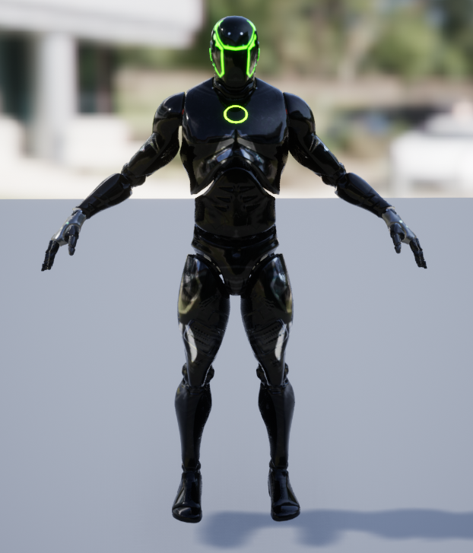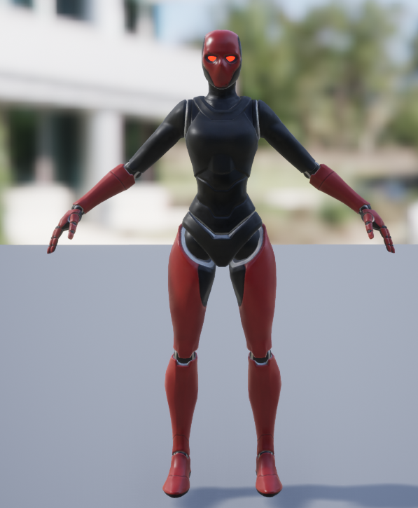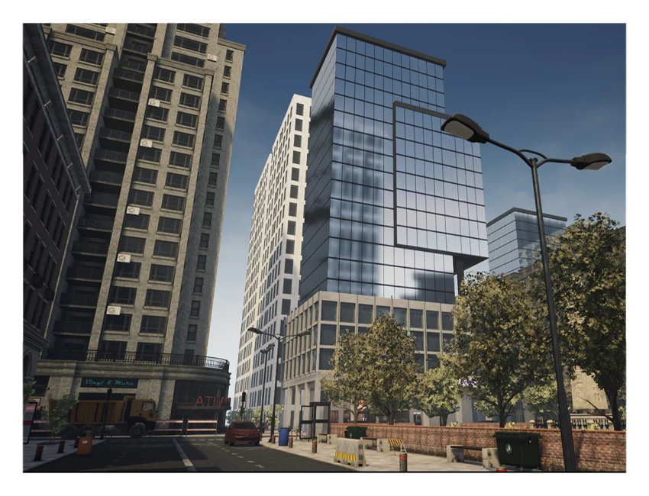

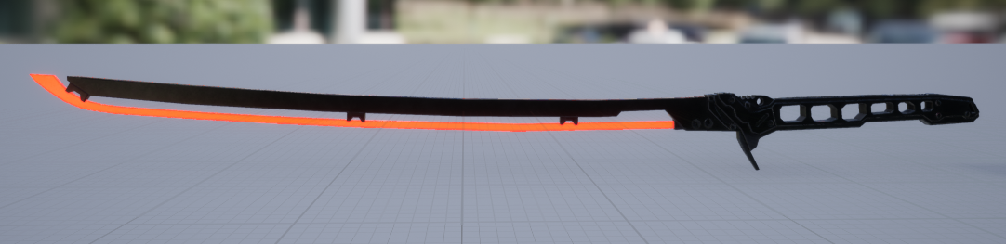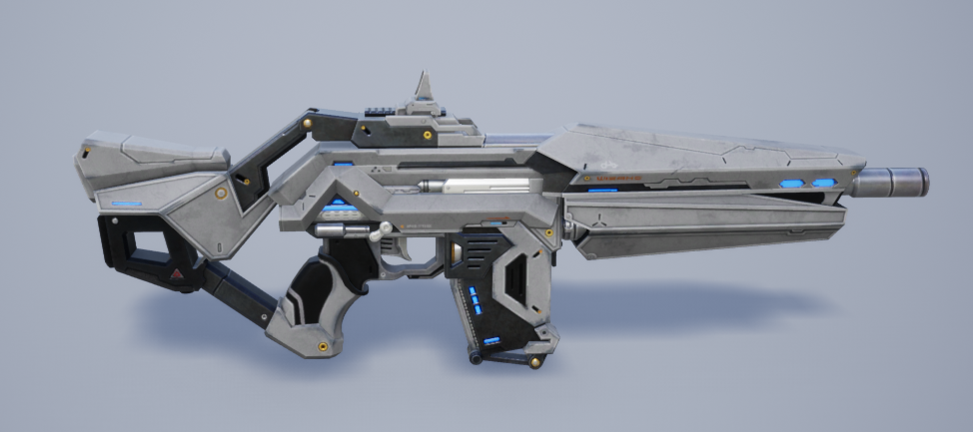

Add read

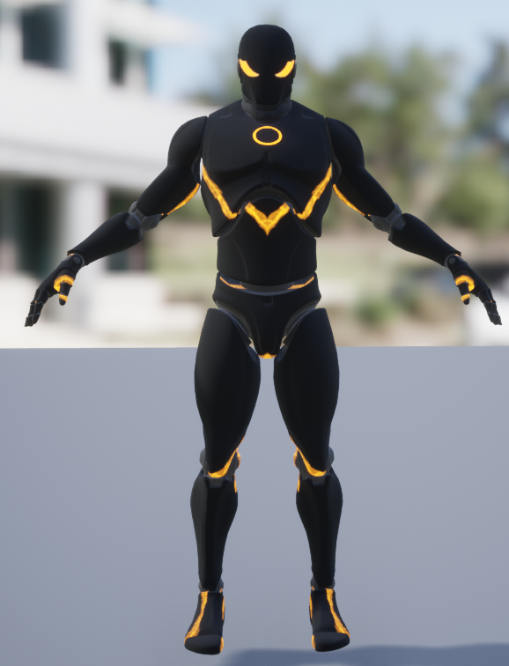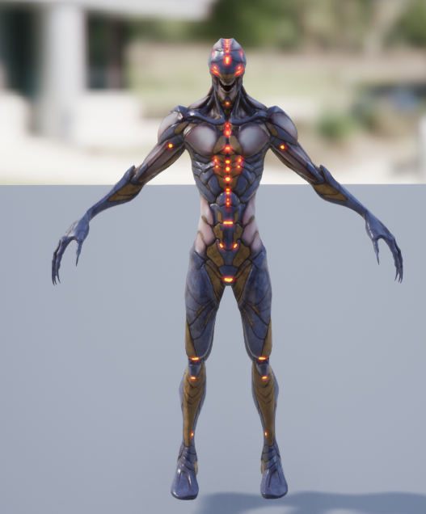 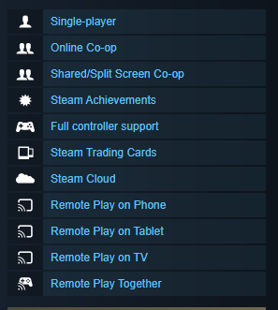

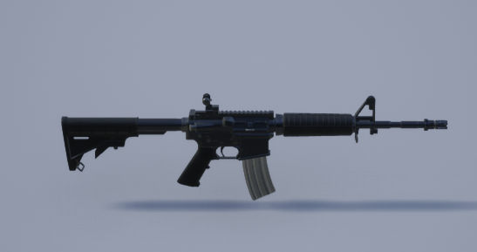

Manufacturer

RELEASE DATE

DEVELOPER:

PUBLISHER:

FRANCHISE:

 tags

SYSTEM REQUIREMENTS

MINIMUM:

* + Requires a 64-bit processor and operating system
  + OS: Windows 7, 8, Windows 10 (64 bit)
  + Processor: AMD FX-8320 (3.5 GHz) / Intel i5-4690K (3.5 GHz) or better
  + Memory: 4 GB RAM
  + Graphics: NVIDIA GeForce GTX 960
  + DirectX: Version 11
  + Storage: 15 GB available space

RECOMMENDED:

* + Requires a 64-bit processor and operating system
  + OS: Windows 7, 8, Windows 10 (64 bit)
  + Processor: Intel Core i7-3930K (3.2 GHz)/AMD Ryzen 5 1600 (3.2 GHz) or better
  + Memory: 8 GB RAM
  + Graphics: NVIDIA GeForce GTX 1060
  + DirectX: Version 11
  + Storage: 15 GB available space
* [Action](https://store.steampowered.com/tags/en/Action/?snr=1_5_9__410)
* [Adventure](https://store.steampowered.com/tags/en/Adventure/?snr=1_5_9__410)
* [Hack and Slash](https://store.steampowered.com/tags/en/Hack%20and%20Slash/?snr=1_5_9__410)
* [Co-op](https://store.steampowered.com/tags/en/Co-op/?snr=1_5_9__410)
* [Multiplayer](https://store.steampowered.com/tags/en/Multiplayer/?snr=1_5_9__410)
* [Local Co-Op](https://store.steampowered.com/tags/en/Local%20Co-Op/?snr=1_5_9__410)
* [Isometric](https://store.steampowered.com/tags/en/Isometric/?snr=1_5_9__410)
* [Action RPG](https://store.steampowered.com/tags/en/Action%20RPG/?snr=1_5_9__410)
* [Top-Down](https://store.steampowered.com/tags/en/Top-Down/?snr=1_5_9__410)
* [RPG](https://store.steampowered.com/tags/en/RPG/?snr=1_5_9__410)
* [Dungeon Crawler](https://store.steampowered.com/tags/en/Dungeon%20Crawler/?snr=1_5_9__410)
* [Loot](https://store.steampowered.com/tags/en/Loot/?snr=1_5_9__410)
* [Gore](https://store.steampowered.com/tags/en/Gore/?snr=1_5_9__410)
* [Singleplayer](https://store.steampowered.com/tags/en/Singleplayer/?snr=1_5_9__410)
* [Top-Down Shooter](https://store.steampowered.com/tags/en/Top-Down%20Shooter/?snr=1_5_9__410)
* [Split Screen](https://store.steampowered.com/tags/en/Split%20Screen/?snr=1_5_9__410)
* [Great Soundtrack](https://store.steampowered.com/tags/en/Great%20Soundtrack/?snr=1_5_9__410)
* [Puzzle](https://store.steampowered.com/tags/en/Puzzle/?snr=1_5_9__410)
* [Fantasy](https://store.steampowered.com/tags/en/Fantasy/?snr=1_5_9__410)
* [Twin Stick Shooter](https://store.steampowered.com/tags/en/Twin%20Stick%20Shooter/?snr=1_5_9__410)